Tutorial 5

Module Name: Shopping & Checkout Module – Defect Identification and Bug
Reporting
Test Case ID: TC05
Tester Name: Vora Riya

Scenarios:
- Scenario ID: 5a
Scenario
Verify login with valid credentials
Test Steps
1. Open SauceDemo.
2. Enter valid username and password.
3. Click Login.
4. Observe the result.

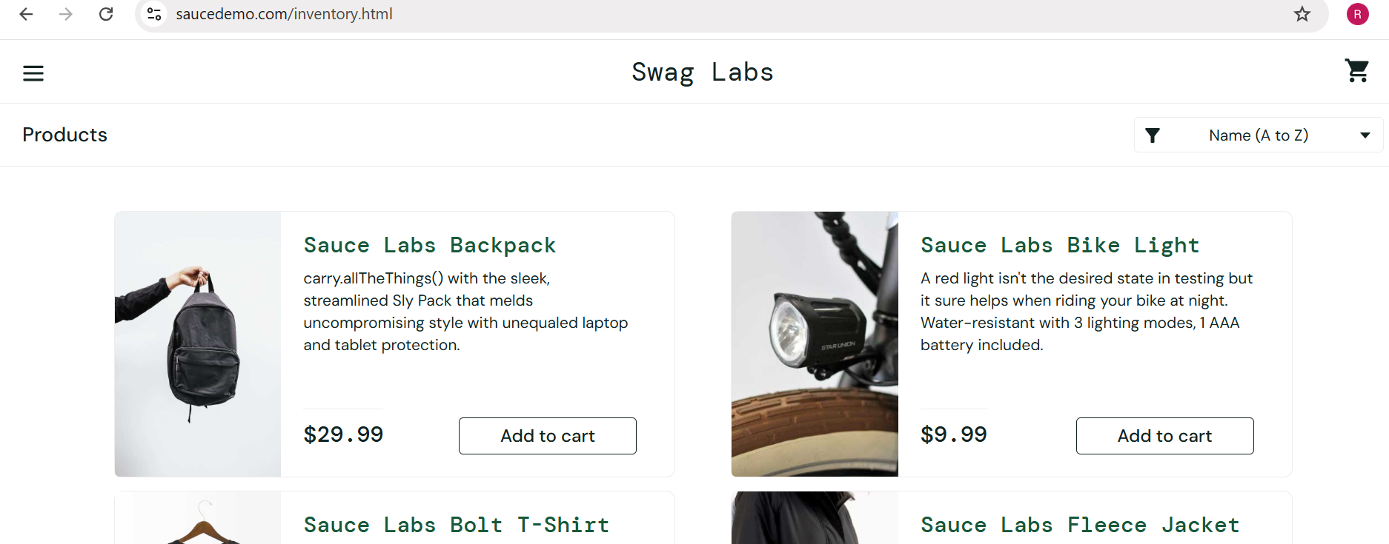

- Scenario ID: 5b
Scenario
Verify login with invalid credentials
Test Steps
1. Open SauceDemo.
2. Enter valid username.
3. Enter incorrect password.
4. Click Login. 5. Observe error.

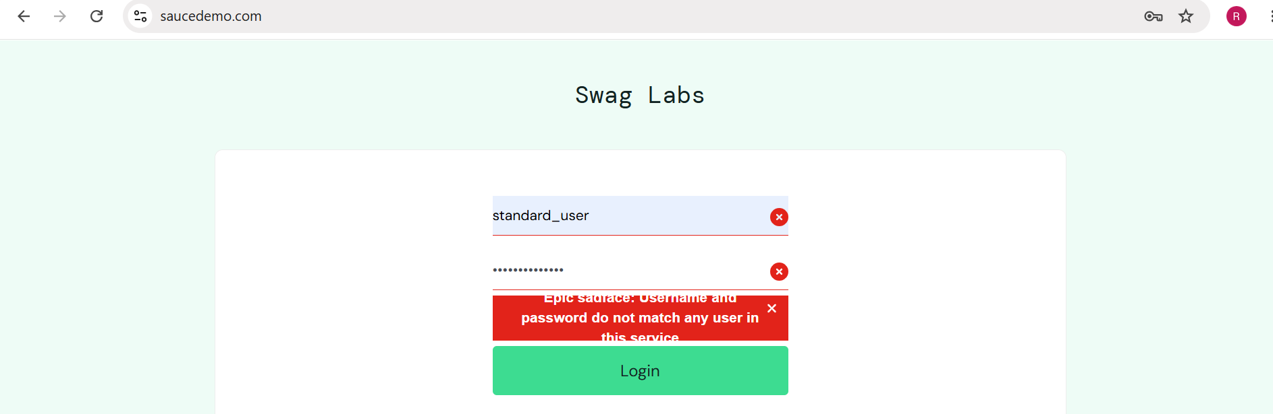

- Scenario ID: 5c
Scenario
Verify product display
Test Steps
1. Login successfully.
2. Open Products page.
3. Observe product details.
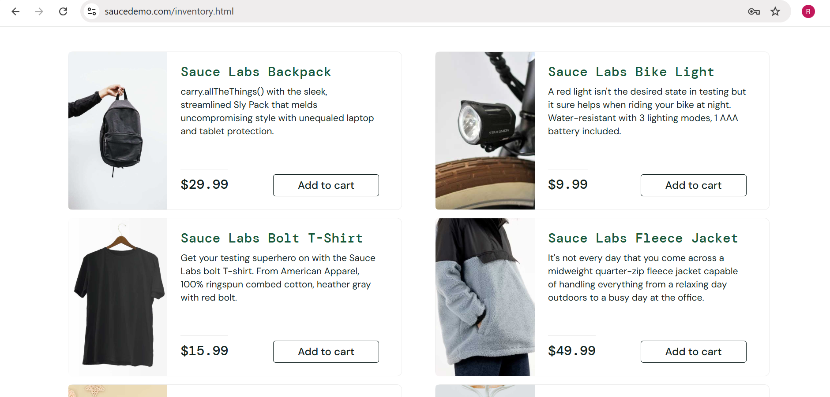

- Scenario ID: 5d
Scenario
Verify Add to Cart functionality
Test Steps
1. Login.
2. Locate Sauce Labs Backpack.
3. Click Add to cart.
4. Observe the result.
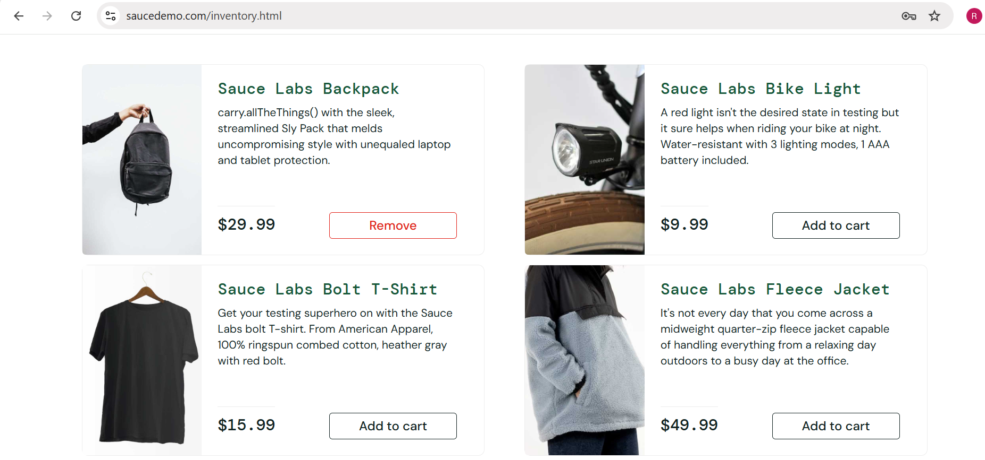

- Scenario ID: 5e
Scenario
Verify product is displayed in Cart
Test Steps
1. Add Sauce Labs Backpack.
2. Click Cart.
3. Verify product name, quantity and price.

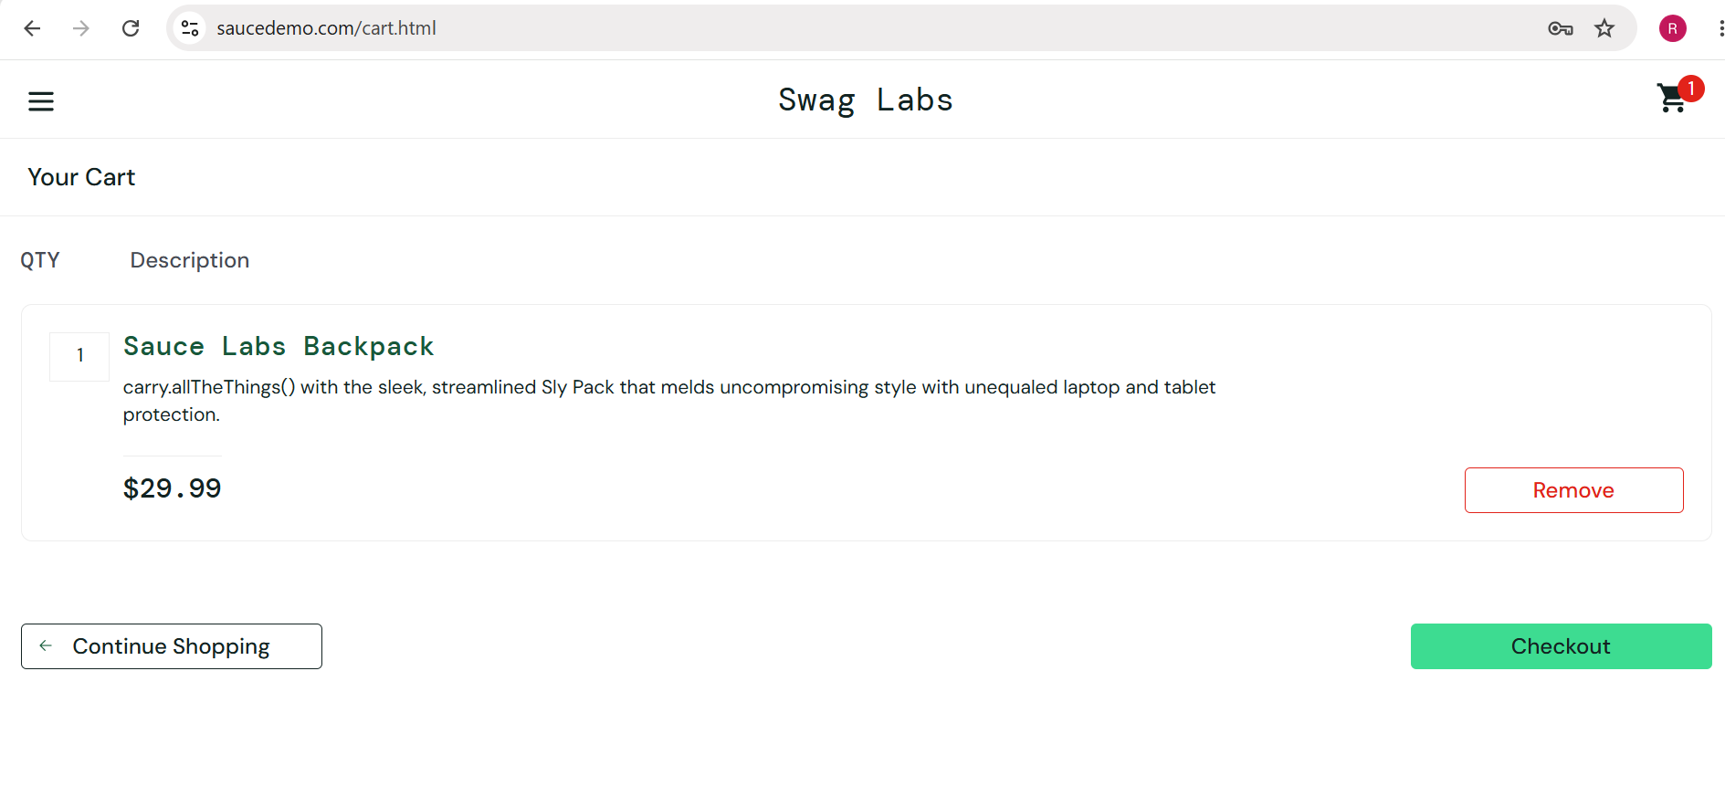

- Scenario ID: 5f
Scenario
Verify Remove from Cart functionality
Test Steps
1. Open Cart.
2. Click Remove beside Sauce Labs Backpack.
3. Observe Cart.
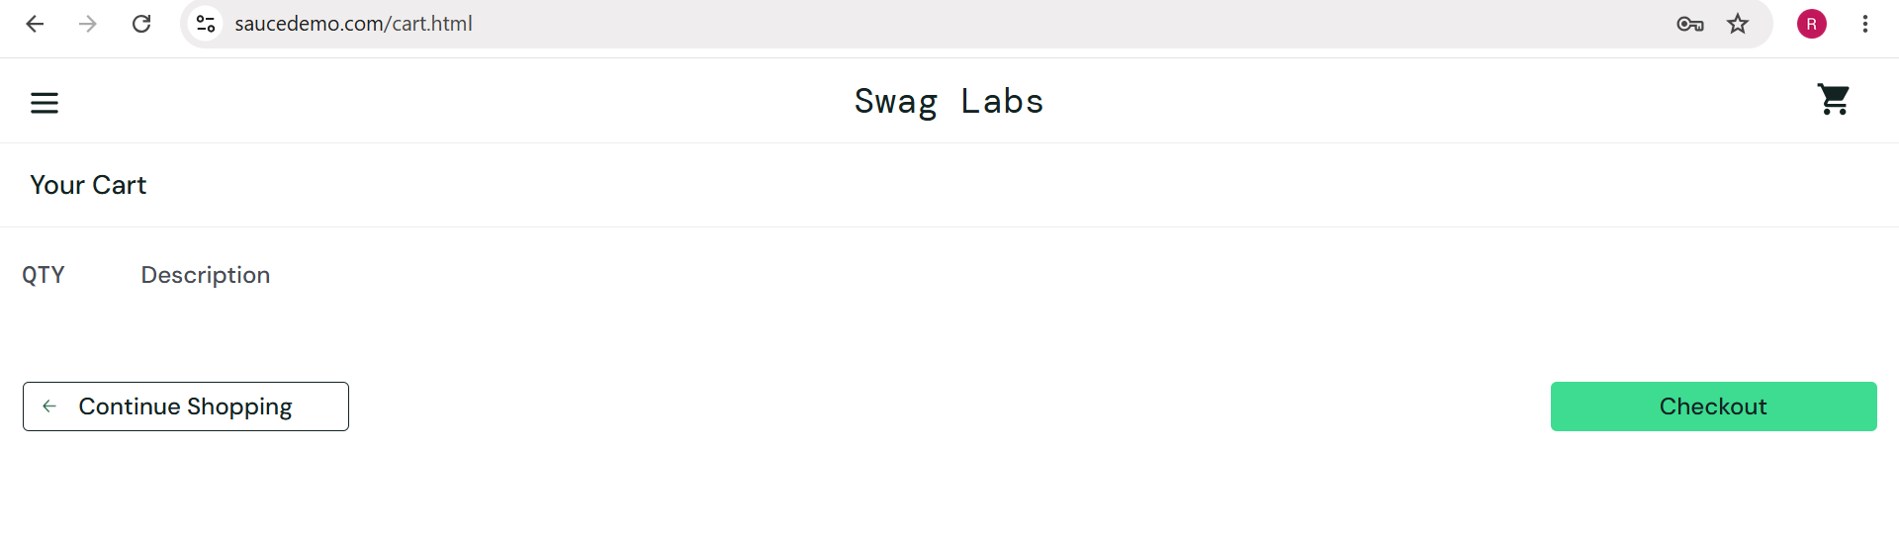

- Scenario ID: 5g
Scenario
Verify checkout proceeds to Checkout Overview
Test Steps
1. Add product to Cart.
2. Open Cart.
3. Click Checkout.
4. Enter customer information.
5. Click Continue.
6. Observe Checkout Overview.

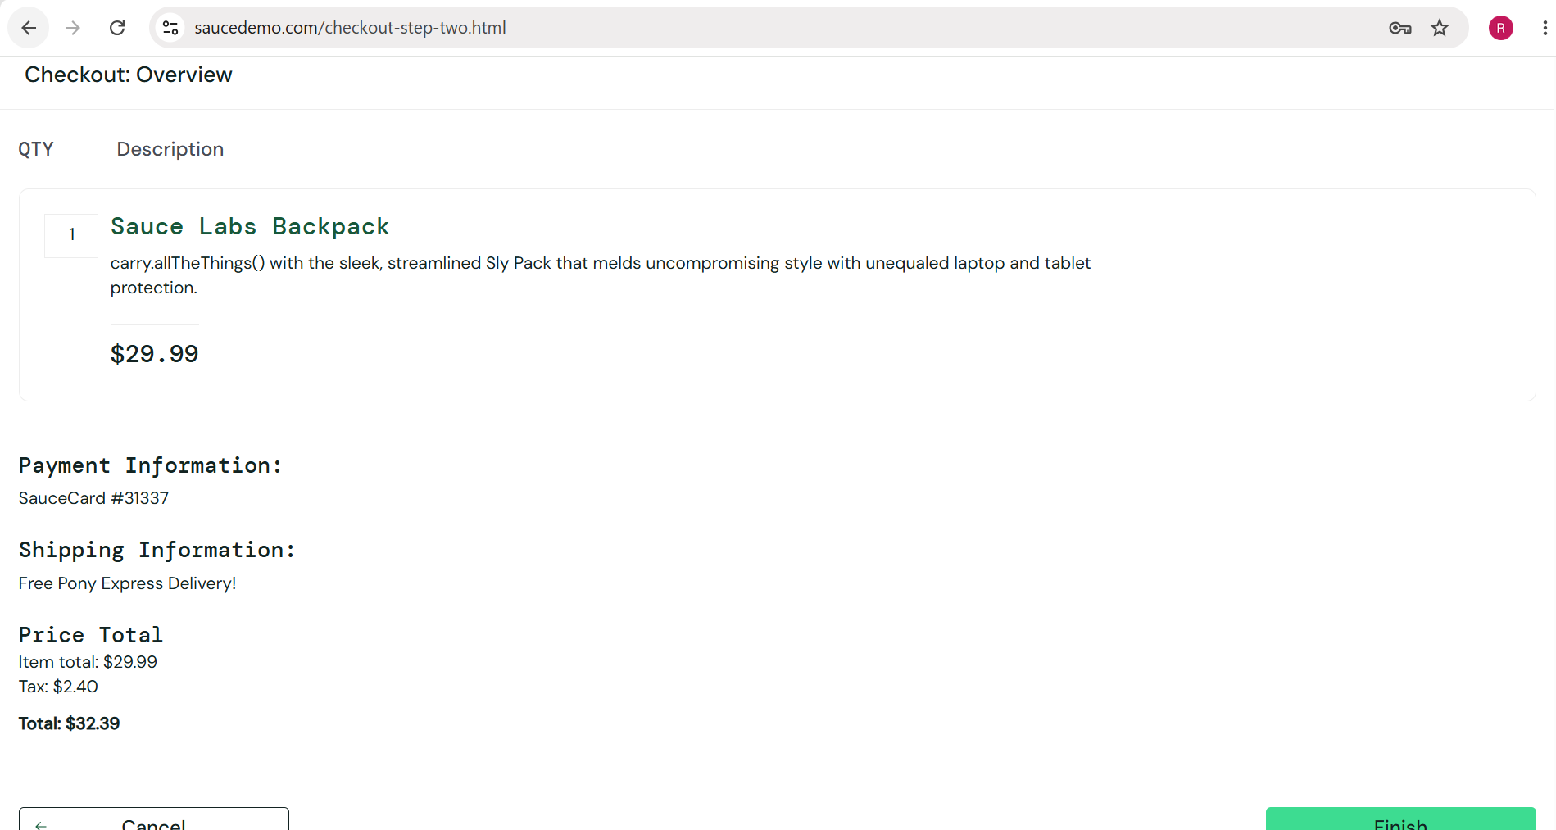

- Scenario ID: 5h
Scenario
Verify Logout functionality
Test Steps
1. Login successfully.
2. Open menu.
3. Click Logout.
4. Observe the result.

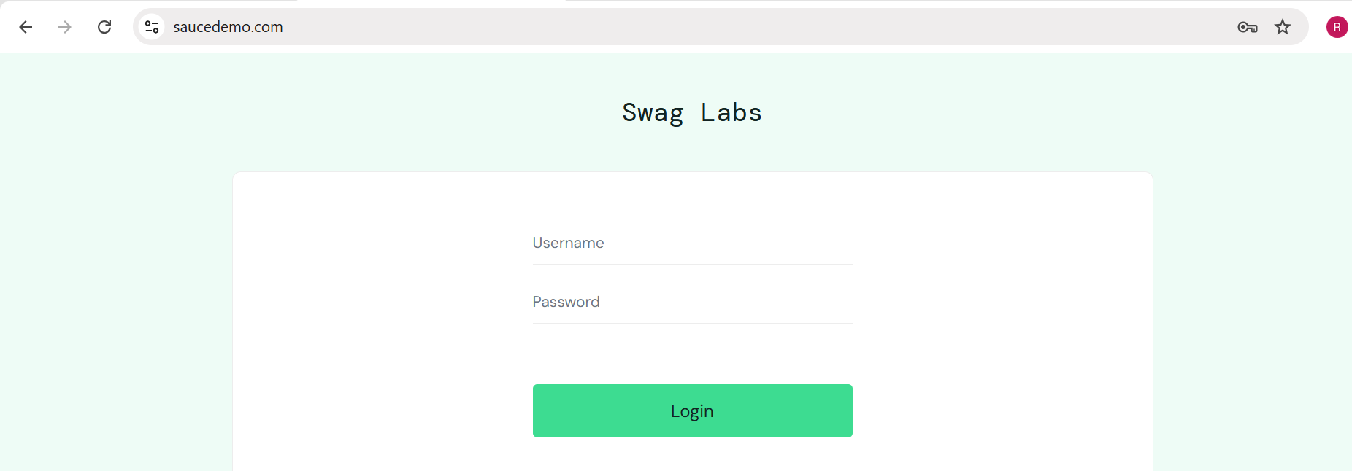

- Scenario ID: 5i
Scenario
Verify Enter-key behavior on Checkout Information form
Test Steps
1. Login.
2. Add product to Cart.
3. Click Checkout.
4. Enter customer information.
5. Press Enter while on the form.
6. Observe navigation.

Bug Report – BUG-001

Field | Details
Bug ID | BUG-001
Bug Title | Pressing Enter on Checkout Information form unexpectedly redirects user to Cart
Module Name | Checkout Module
Feature Affected | Checkout Information Form
Defect Type | Functional / Navigation Defect
Severity | Medium
Priority | Medium
Environment | SauceDemo – Google Chrome
Reported By | Vora Riya
Status | Open

- When valid customer information is entered on the Checkout: Your Information page and the Enter key is pressed, the application unexpectedly redirects the user back to the Your Cart page instead of remaining on the Checkout Information page.

Test Data
Username: standard_user
Password: secret_sauce
First Name: test
Last Name: case
Postal Code: 3800146
Expected Result
Pressing the Enter key should not unexpectedly redirect the user away from the Checkout Information page.
Actual Result
Pressing the Enter key redirected the user from the Checkout: Your Information page back to the Your Cart page.

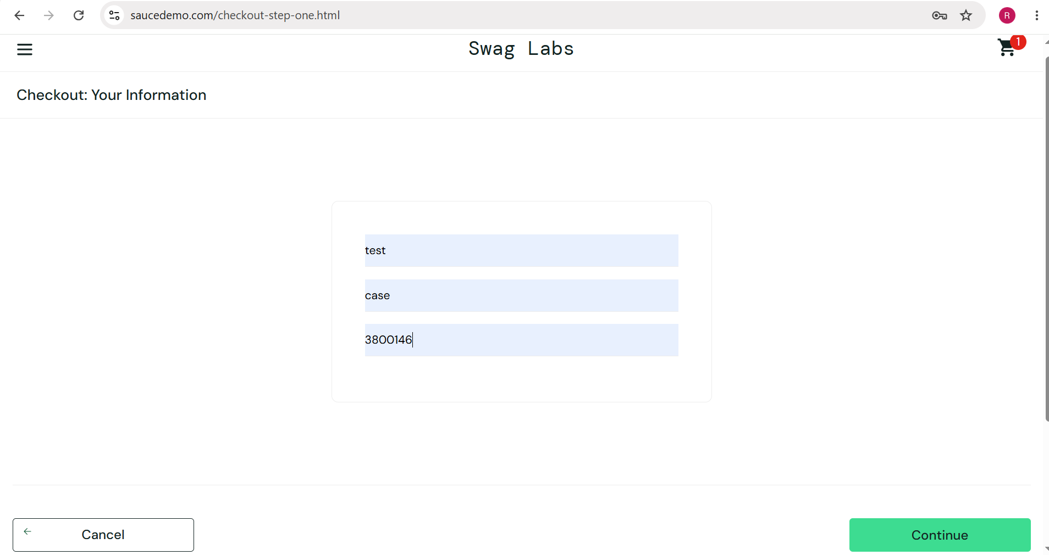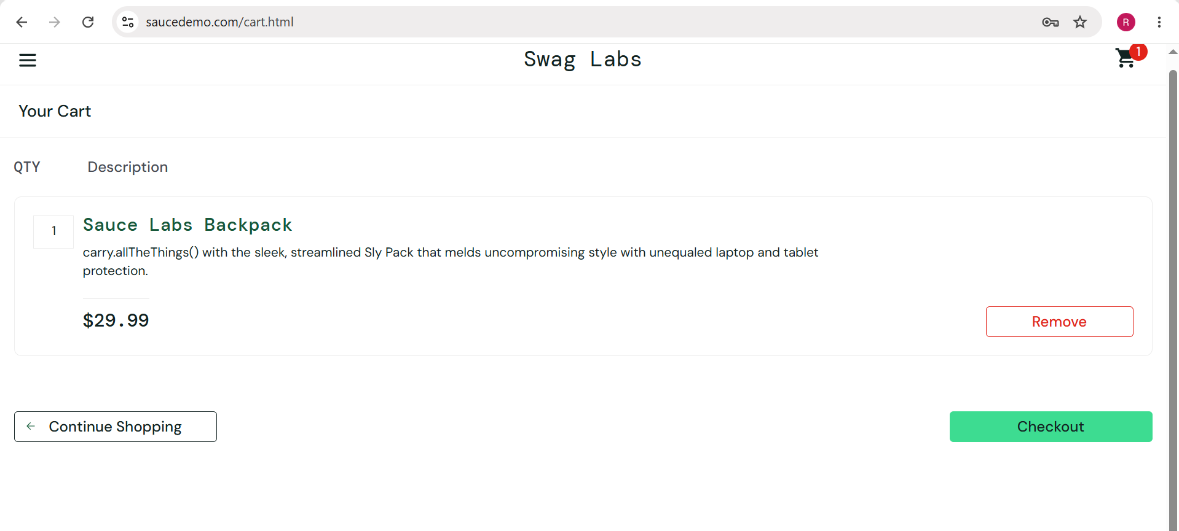

Test Result Summary

Total Test Case | Pass | Fail
9 | 8 | 1

